Technical Design and Specification

Climate & Weather

Confidential and Proprietary Information
This document contains information that is proprietary to Monash University. Transmittal, receipt, or possession of this document does not express license, or imply rights to use, sell, design, manufacture, or to have manufactured, any product, concept, or service from this information. No reproduction, publication, or disclosure of this information, in whole or in part, electronic or otherwise, shall be made without prior written authorization of an officer of Monash University
Authorized transfer of this document from the custody and control of Monash University constitutes a loan for limited purpose(s), and this document must be returned to Monash University upon request, and in all events, upon completion of the purpose(s) of the loan.

Document Change Log

Prepared By | Module | Date | Version
Simon Yu |  | 11/09/2010 | V0.1
Simon Yu |  | 16/09/2011 | V1.0

Revisions

Modified By | Reason | Date | Version

Table of Contents

1. Introduction 4
1.1. Purpose 4
1.2. Scope 4
1.3. Audience 4
2. Design Overview 4
2.1. Approach 4
2.2. Architectural Goals and Constraints 5
2.3. Guiding Principles 5
2.4. Design Patterns 5
2.5. Design Principles 6
3. Detailed Design 7
3.1. Architecture Diagram 7
3.2. Application Architecture 8
4. Components and Processes 9
4.1. Components 9
4.2. Persist Architecture 10
4.3. Dataset File Structure 11
5. Interfaces 12
5.1. Collection Create Interface 12
5.2. Collection Update Interface 12
5.3. Collection Delete Interface 12
5.4. Import Dataset Interface 12
5.5. Export Dataset Interface 12
5.6. Staging Transferring Interface 12
5.7. User Permission Interface 12
5.8. RIF-CS Generating Interface 12
5.9. User Login Interface 12
5.10. User Registration Interface 12
5.11. Handle Persistent Identifier Create Interface 12
5.12. Activity and Party Query Interface 13
6. Security 13
6.1. User Authentication and Authorization 13
6.2. Security Model 13
6.3. Using HTTPS Protocol Communication 14
7. Reuse 14
8. Test Plan 14
8.1. Unit testing 14
8.2. Integration testing 14
9. Extensibility 15
10. Nonimplemented tasks 15
11. Summary 15

Introduction

Purpose
The purpose of this document is to outline the technical design of the Climate and Weather Data Capture Project and provide an overview for the Climate and Weather Data Capture Project Implementation.
Its main purpose it to
- Provide the link between the Functional Specification and the detailed Technical Design documents
- Detail the functionality which will be provided by each component or group of components and show how the various components interact in the design
- Provide a basis for the Climate and Weather Data Capture Project’s detailed design and development

This document is not intended to address installation and configuration details of the actual implementation.

As is true with any high level design, this document will be updated and refined based on changing requirements.

Scope
The application Design outline in this document builds upon the scope defined in the Requirements phase.

Audience
The intended audiences for this document are stakeholders, the project development teams, technical architects, database designers, testers and vendors.

Design Overview

Approach
This document is created and extended in multiple phases over the project -
- Requirements Phase – During the Requirements Phase, the initial version of this document is created, describing the candidate architecture to be validated in the System Design Phase.
- System Design Phase – During the System Design Phase, the Evolutionary Prototype is created and this document is finalized by establishing a sound architectural foundation for Construction Phase.
- Construction Phase – During the Construction Phase, this document is not expected to change radically; it is mainly updated to reflect changes in any interface definitions.
- Transition / Training Phase – During the Transition / Training Phase, no further additions or modifications are made to this document.

Architectural Goals and Constraints
The overall architectural goals of the system is to provide a highly available and scalable the Climate and Weather Data Capture System for researchers in Monash.

A key Architectural goal is to leverage industry best practices for designing and developing a scalable, enterprise-wide J2EE application. To meet this goal, the design of the Climate and Weather Data Capture project will be based on core J2EE patterns as well as the industry standard developing guidelines.

Guiding Principles
Guiding principles provide a foundation upon which to develop the target architecture for the Climate and Weather Data Capture Project, in part by setting the standards and measures that the system must satisfy. These in turn drive design principles that can be used to validate the design and ensure that it is aligned with overall Data Capture and Metadata Store Project Architecture, Design Principles and Standards.

Some of the guiding principles that will be followed during the system design and development are outlined below.

Scalable
Scalability is the ability of the platform to scale both up and down to support varying numbers of users or transaction volumes.

Flexible
Flexibility is the ability of the system to adapt and evolve to accommodate new requirements without affecting the existing operations. This relies on a modular architecture, which isolates the complexity of integration, presentation, and business logic from each other in order to allow for the easy integration of new technologies and process within the system.

Standards-Based
System services will comply with established industry standards. The standards-compliance will not only apply to system development but also to design, platform/infrastructure and other parts of the Data Capture Project, Examples of standards include HTML, XML, J2EE, AJAX, FreeMarker, Struts2, Hibernate and Spring.

Design Patterns
Design patterns are elements of reusable object oriented software. A design pattern catalog is a repository of design patterns. Use of such patterns makes the design of a system transparent. These patterns have been used successfully by developers in their respective fields, and therefore, the pros and cons of the pattern (as well as implementation issues) are known beforehand. All design patters are reusable and can be adapted to particular contexts.

Some of the design pattern that will be used in the design and development of the Data Capture project are -
- MVC Model
- DAO (Data Access Object)
- Spring IoC

MVC Model
The Model-View-Controller design pattern solves interdependencies between data access code, business logic code and presentation code by decoupling data access, business logic, and data presentation and user interaction.

DAO (Data Access Object)
The Data Access Object pattern helps to decouple the business logic from the database thus increasing the portability of the system.

Spring IoC
Inversion of Control or IoC is one of the techniques used to wire services or components to an application program. In Spring, the IoC principle is implemented using the Dependency Injection design pattern which leaves the system components loosely coupled and allows developer to code to abstractions.

Design Principles
Best practices and design principles will be applied in two main areas –
- Presentation Layer should be uncoupled
- Presentation Layer is delivered to a web browser rather than to custom client software. A range of modern browsers that support HTML, DHTML, and XML are required.
- A common look and feel for the system.
- Ajax technology should be used for validating user input and prevent round trips between the browser and the server
- The user interface will be designed in such a way that common user interface Functionality will be implemented in a similar manner across the board. Examples of this include:
- A consistent way of capturing date inputs
- A uniform way of displaying informational and error messages to the users
- A uniform way of displaying required and optional fields in the screens.

- Business Rules should be encoded within the application development framework
- Business rules will need to be separated from the presentation and database frameworks
- Standard frameworks for encoding business rules and events will need to be used.
- Adoption of a component based framework needs to be considered to promote reuse of information objects.

Detailed Design

Architecture Diagram
The diagram below provides a illustration of the system architecture along with various system components that will be used in the Climate and Weather Data Capture Project.

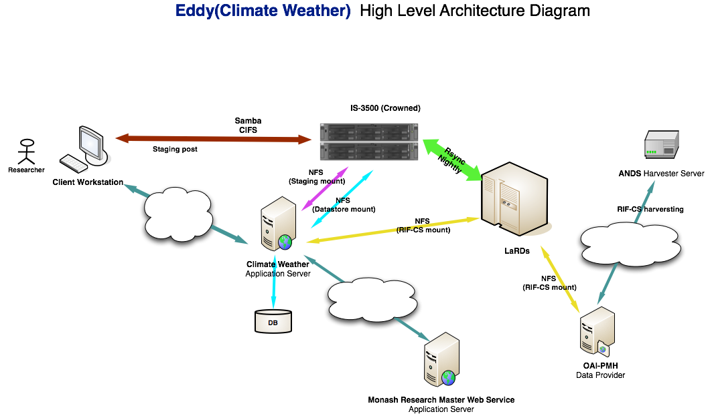

- Apache Server – The web server is responsible for serving web pages, via the HTTPS protocol to clients.

- Tomcat Application Server – The application server hosts the Climate and Weather Data Capture System and hosts the business logic and the business model classes of applications. It serves requests for dynamic HTTP web pages from Web servers.

- Database Server – The database server persists the metadata and data for the Climate and Weather System.

- IS3500 Server – Staging post server and data storage server.

- LaRDs Storage - LaRDs storage server backup the Climate and Weather system Data.

- Monash Research Master Web Service – Provides the Party and Activity Service

- OAI-PMH Data Provider - Provides the RIF-CS feeding into the ANDS Collections Registry

Application Architecture
Application architecture defines the various components and their interactions in context of a whole system. Application architecture is the critical software that bridges the architectural gap between the application server and the application’s business logic, thereby eliminating the complexities and excessive costs of constructing, deploying and managing distributed enterprise applications.

The system will have a layered application architecture which provides some of the key features below:
- Structure: Organizing applications along business-level boundaries and not technical boundaries
- Speed and Flexibility: Marking application changes through configuration and not programming
- Control: Modifying, extending or overwriting any architectural element
- Reuse: Achieving greater reusability and integration by loosely coupling application logic to infrastructure.

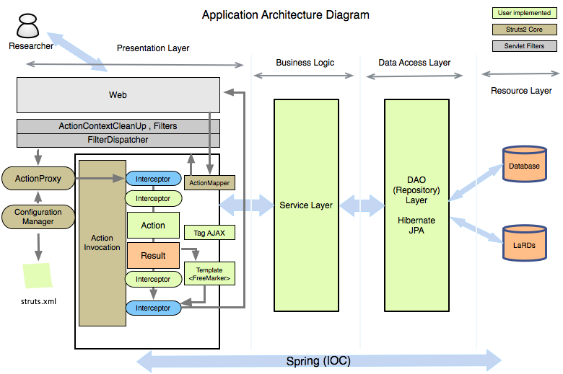

Presentation Layer
A standard Internet Browser such as Internet Explorer, Firefox is the primary client for the the Climate and Weather application. HTML pages are delivered to the client browser by the the Climate and Weather application upon a user request. The Web Pages are FreeMarker templates which will be rendered by FreeMarker engine into html pages.

Content Layer
The content layer as the name signifies is the front-end information layer that the end-user interacts with. Data-to-Content Conversion and Content-to-Data Conversion are two primary responsibilities of this layer. Struts2 technology will be used in this layer.

Business Logic Layer
The business logic layer will implement the business rules for the application. It will host the business service components as well as business objects. The business components will implement the following:
- Business rules, such as data injection and validations
- Interfaces between the user interface and the data access layer

Data Access Layer
Data access layer using Hibernate JPA will manage the domain objects into the database. Persistence can be complex in large applications using protocols like JDBC, Neither the client nor the business component needs to be aware of this complexity. Moreover there are many forms of storage from databases, to flat files. Decoupling the persistence logic from the business components and client allows for a flexible, easy to maintain application. The DAO (data access object) pattern allows for the abstraction of the persistence from the business component. The DAP encapsulates all access to the data store.

Resource Layer
The resource layer includes the underlying resources that the application uses to deliver its functionality. This includes using a Database and file system to persist information.

Components and Processes

Components

Authentication and Authorization Service
Authentication and Authorization Service - provide user registration, login, access permissions

Data Management Service
Data Management Service - provides the data collection CRUD functionalities, data collection sharing. Metadata searching, Net-CDF files (processing data) importing, exporting and staging transferring functionalities.

Persist Identifier Service
Persist Identifier Service – it is a web service client implementation of the handle persist identifier service, and create a persist identifier for a data collection.

RIF-CS Service
RIF-CS Service – creates a RIF-CS format Metadata file based on the AOI-PMH protocol.

Party and Activity Service
Party and Activity Service – It’s a web service client implementation of the Party and Activity Web Service

Persist Architecture
The Climate and Weather Data Capture application will use the Postresql database and the File system (LaRDS) as it repository.

Data Model
The Data Model is a method for describing data structures and a set of operations used to manipulate and validate that data.

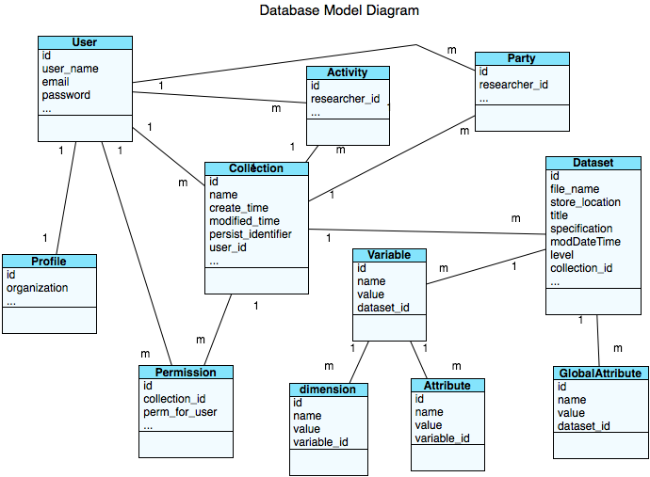

Dataset File Structure
Dataset file structure is a method for describing the dataset file structure and how to store to it into a well-form file structure.

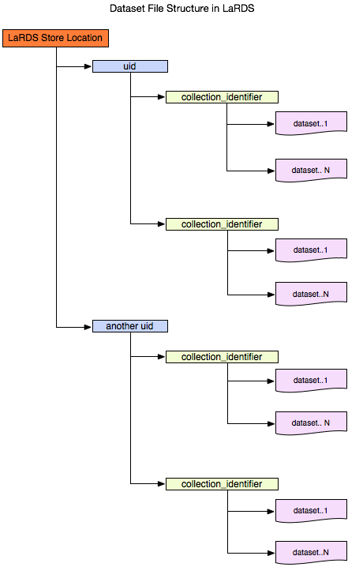

Interfaces

Collection Create Interface
The collection create interface will provide a collection creation functionality. Which group the datasets based on the same monitoring site.

Collection Update Interface
The Collection Update Interface will provide a researcher to update a collection if any changes required.

Collection Delete Interface
The Deleting of Collection interface will provide a collection deleting functionality if a collection needs to be removed from the repository.

Import Dataset Interface
The Dataset Importing Interface will import the dataset into the repository.

Export Dataset Interface
The Dataset Exporting Interface will provide a researcher to download the dataset into local pc.

Staging Transferring Interface
The staging transferring Interface will provide the batch data transferring service, and with metadata extraction enabled functionality.

User Permission Interface
The User Permission Interface will provide user permissions control interface.

RIF-CS Generating Interface
The RIG-CS Generating Interface will provide generating a RIF-CS metadata format file based on AOI-PMH interface and persist metadata in the repository.

User Login Interface
The User Login Interface will provide an user login interface which will support LDAP-User login and Self-Registered User login functionality.

User Registration Interface
The User Registration Interface will provide an user registration interface which will support LDAP-User registration and Non-LDA-User registration.

Handle Persistent Identifier Create Interface
The handle persistent Identifier Create Interface will provide a web service client implementation of handle persistent identifier Web Service.

Activity and Party Query Interface
The Activity and Party Query Interface will provide a web service client implementation of Activity and Party Web Service.

Security

User Authentication and Authorization
- Only a registered user can create collections and import the datasets into repository.
- A pubic user only can view the public collection and public datasets
- A registered user can share his / her data collection with other

Security Model
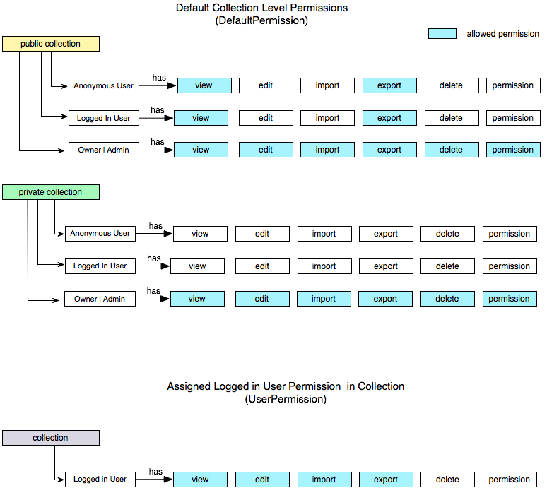

Default Permissions of collection
The collection can be set as a public collection or a private collection.

The default permissions of a public collection are view and export. An owner of a collection or an admin has full permissions in a collection.

An owner of a collection can set default permissions to anonymous user or all logged in users in a public collection. An owner of a collection also can set a special permission to a logged user.

A private collection has no permission except the collection owner and admin who have a full permission.

An owner of a collection can set default permissions to anonymous user or all logged in users in a private collection. An owner of a collection also can set a special permission to a logged user.

Changing a collection from public into private, all default permissions will be reset as a private default permission values. Changing a collection from private to public, all default permission will reset to a default public collection permission values.

Using HTTPS Protocol Communication
Using HTTPS protocol communication between users and application to ensure data security and integrity.

Reuse
The system should support for different dataset file formats which makes application easy to be reused by another project. In order to support different dataset file formats the system should provide different file importing adaptor to extract the metadata from the dataset.

Test Plan

Unit testing
The unit testing is a method by which individual units of source code are tested to determine if they are fit for use. JUnit testing framework will be used in unit testing.

Integration testing
The Integration Testing is a logical extension of unit testing. Integration testing identifies problems that occur when units are combined. By using a testing plan that requires developers or testers to test each unit and ensure the viability of each before combining units, the developers know that any errors discovered when combining units are likely related to the interface between units.
Three common testing strategies will be used during the integration testing:

- The top-down approach to integration testing requires the highest-level modules be test and integrated first. This allows high-level logic and data flow to be tested early in the process and it tends to minimize the need for drivers. However, the need for stubs complicates test management and low-level utilities are tested relatively late in the development cycle. Another disadvantage of top-down integration testing is its poor support for early release of limited functionality.
- The bottom-up approach requires the lowest-level units be tested and integrated first. These units are frequently referred to as utility modules. By using this approach, utility modules are tested early in the development process and the need for stubs is minimized. The downside, however, is that the need for drivers complicates test management and high-level logic and data flow are tested late. Like the top-down approach, the bottom-up approach also provides poor support for early release of limited functionality.
- The third approach, sometimes referred to as the umbrella approach, requires testing along functional data and control-flow paths. First, the inputs for functions are integrated in the bottom-up pattern discussed above. The outputs for each function are then integrated in the top-down manner. The primary advantage of this approach is the degree of support for early release of limited functionality. It also helps minimize the need for stubs and drivers. The potential weaknesses of this approach are significant, however, in that it can be less systematic than the other two approaches, leading to the need for more regression testing.

Extensibility
Struts2, Hibernate and Spring2 are extensible frameworks for building enterprise-ready java web application. Which makes Climate & Weather Data Capture Application more scalable and extensible when a new functionality or modification of existing functionality required.

Nonimplemented tasks
None.

Summary
The system will be built as part of the ANDS funded Monash ARDC-EIF Data Capture and Metadata Store Project. This project aims to develop software solutions that:
- Capture data and metadata from research instruments and devices
- Data staging transfer
- Make available and automate feeds of data collection descriptions
- Enable data/metadata management and sharing
- Facilitate the re-use and discovery of data
- Recognise the need to facilitate the overall data stream/s from Monash to the RDA which include collections with related party and activity descriptions in compliance with the requirements set out in the ANDS Minimum Metadata Contents for RIF-CS

The system will be fully integrated with the Research Australia Service so that the metadata of the research data is discoverable by the broader national and international research community. The system will support a range of scientific data formats, like NetCDF (Network Common Data Form), GRIB2 (GRIdded Binary) which makes the creation, access and sharing of scientific data easy.

In addition, the system will be a multiple-tier web-centric application and a proven classic design MVC pattern will be adopted. Each component of the system is independent and so applicable to future developing and easy maintaining. The system will also use the Monash Large Research Data Storage (LaRDS) service, which makes the research data reliably backed-up and secure.

